**PROJECT REPORT**

**ADAPTIVE TRAFFIC COTROL SYSTEM**

**BY**

**PRASHANT KUMAR 10300117065**

**POOJA KUMARI 10300117067**

**RAHUL PANDEY 10300117063**

**UNSER THE GUIDENCE OF**

**PROF. RAJESH MUKHERJEE**

**(Assistant Professor, Haldia Institute of Technology)**

**REPORT SUBMITED IN FULFILMENT OF THE REQUIREMEENTS FOR THE DEGREE OF BACHELOR OF TECHNOLOGY**

**IN**

**COMPUTER SCIENCE AND ENGINEEEING**

***HALDIA INSTITUTE OF TECHNOLOGY***



**DECLARATION**

We certify that

1. The work contained in this report is original and has been done by us under the guidance of our supervisor(s).
2. The work has not been submitted to any other Institute for any degree or diploma.
3. We have followed the guidelines provided by the Institute in preparing the report.
4. We have conformed to the norms and guidelines given in the Ethical Code of Conduct of the Institute.
5. Whenever we have used materials (data, theoretical analysis, figures, and text) from other sources, we have given due credit to them by citing them in the text of the report and giving their details in the references.

Signature of the Students

Prashant Kumar 10300117065

Pooja Kumari 10300117067

Rahul Pandey 10300117063

**CERTIFICATE**

This is to certify that the Dissertation Report entitled, “**Adaptive traffic control System**” submitted by **Mr./Ms.** “**Prashant Kumar, Pooja Kumari & Rahul Pandey**” to Haldia Institute of Technology, Haldia, India, is a record of bona fide Project work carried out by him/her under my/our supervision and guidance and is worthy of consideration for the award of the degree of Bachelor of Technology in Computer Science and Engineering of the Institute.

Supervisor Supervisor

Date:08/07/2021

## ***ACKNOWLEDGEMENT***

We take this opportunity to express my profound gratitude and deep regards to our mentor Prof. Rajesh Mukherjee for his exemplary guidance, monitoring and constant encouragement throughout the course of this project. The blessings, Help and guidance given by his time to time will carry me a long in the journey of life on which we are about to embark.

We are obliged to our all-project team members for the valuable information provided by them in their respective fields. We are grateful for their cooperation during the period of assignment.

STUDENTS INFORMATION PAGE

|  |  |
| --- | --- |
| NAME: | RAHUL PANDEY |
| PERMANENT ADDRESS: | VILLAGE-KHANAW, POST-MANIHARI, DISTRICTKAIMUR (BHABUA), BIHAR-821101 |
| PHONE NUMBER: | 9113464686 |
| EMAIL-ID: | rahulpandey21101997@gmail.com |
| NAME: | PRASHANT KUMAR |
| PERMANENT ADDRESS: | Ward no 17, Pojhiyan, Lalganj, Vaishali 844121 |
| PHONE NUMBER: | 6295723592, 8597160404 |
| EMAIL-ID: | prashantk801@gmail.com |
| NAME: | POOJA KUMARI |
| PERMANENT ADDRESS: | SHANTI NIWAS PATH, BAHAURPUR HOUSING  COLONY, NEAR AMARNATH MANDIR, PATNA800026 |
| PHONE NUMBER: | 9123438527 |
| EMAIL-ID: | poojadurgesh1999@gmail.com |

## ***Table of Contents***

1. ABSTRACT (i)
2. INTRODUCTION (1)
3. RELATED WORKS (3)
4. PROPOSED METHOD (5)
5. METHODOLOGY (8)
   1. LAMMER’S ADAPTIVE TRAFFIC SIGNAL CONTROL ALGORITHMS
   2. REINFORCEMENT LEARNING
6. REASEARCH BASED ON FUTURE TRAFFIC ENVIRONMENT (15)
7. ALGORITHMS FOR THE SMART TRAFFIC CONTROL (20)

SYSTEM

* 1. EVSP PROCESS
  2. TRAFFIC SIGNAL CONTROL ALGORITHM

### 7.3. TRAFFIC SIGNAL SWITCHING AND COMPENSATION

MODE (50)

8. CONCLUSION AND FUTURE WORKS

## ***ABSTRACT***

The self-adaptive traffic signal control system serves as an effective measure for relieving urban traffic congestion. The system is capable of adjusting the signal timing parameters in real time according to the seasonal changes and short-term fluctuation of traffic demand, resulting in improvement of the efficiency of traffic operation on urban road networks. The development of information technologies on computing science, autonomous driving, vehicle-to-vehicle, and mobile Internet has created a sufficient abundance of acquisition means for traffic data. Great improvements for data acquisition include the increase of available amount of holographic data, available data types, and accuracy.

The article investigates the development of commonly used self-adaptive signal control systems in the world, their technical characteristics, the current research status of self-adaptive control methods, and the signal control methods for heterogeneous traffic flow composed of connected vehicles and autonomous vehicles. Finally, the article concluded that signal control based on multiagent reinforcement learning is a kind of closed-loop feedback adaptive control method, which outperforms many counterparts in terms of real-time characteristic, accuracy, and self-learning and therefore will be an important research focus of control method in future due to the property of “model-free” and “self-learning” that well accommodates the abundance of traffic information data. Besides, it will also provide an entry point and technical support for the development of Vehicle-to-X systems, Internet of vehicles, and autonomous driving industries. Therefore, the related achievements of the adaptive control system for the future traffic environment have extremely broad application prospects.

## ***INTRODUCTION***

The amount of motor vehicles and correspondent travel demand are continuously increasing with economic and social development. The frequent occurrence of traffic congestion in urban road network has negative impacts on economy and environment. Due to the limited land resources of large cities and restrictions to transportation infrastructure construction from socioeconomic factors, to apply traffic management and control measures in a reasonable and effective way, improve the efficiency of existing transportation facilities, and accommodate the growing traffic demand in big cities have become significant research contents for counteracting urban traffic congestion.

Traffic control is one of the most important technical means to regulate traffic flow, improve the congestion, and even reduce emissions. Its progress and development have always been accompanied by the development of information technology, computer technology, and system science. The self-adaptive control system can adjust the signal timing parameters in real time according to the control target of the manager (such as the minimum delay of the intersection) and the arrival characteristics of the traffic flow at the intersection. Compared with timing control and actuated control, the self-adaptive control system can make better use of the overall traffic capacity of the road network and effectively improve the efficiency of road network traffic.

## ***RELATED WORKS***

This section gives a brief review of various approaches that have been employed to solve problems. This section gives a brief review of various approaches that have been employed to solve problems associated with adaptive traffic control using algorithms. The algorithm adopted the use of inter-arrival and inter-departure times to simulate the leaving of vehicles. The model provided good and satisfactory results of the Average Waiting time. A distributed algorithm for adaptive traffic light control which decides in a dynamic fashion, the green light sequences by selecting movements comprising of each phase and its duration was developed by. The system model made use of sensors organized into four hierarchical layers with several communication paths. To ensure that the proposed method is plausible, simulations were conducted with positive results for the minimization of the average waiting time. Real-time parameters such as traffic density and queue length were obtained by using image-processing techniques for the two junctions. The system was designed to consider emergency vehicles (ambulance, police unit, and fire brigade) coming from three different directions at the same time with different speed ratio. In the case of time-varying traffic, the proposed Fuzzy Logic System Control (FLSC) was superior to the fixed time controller. In the work of an algorithm for vehicle queuing system using the Monte Carlo simulation technique was developed to reduce vehicle waiting time and vehicle queues at intersections in an urban region. The design of an adaptive traffic light controller using fuzzy logic method was used to determine the green time interval at an intersection. Three inputs namely the number of queues, waiting for time and traffic flow of vehicles were determined using simulation. Results showed that the traffic light using fuzzy logic control performed better than the fixed time control.

The collection of data was achieved using a video imaging system. real-time decision that determined the interval of green light time for each traffic light at each intersection was achieved. It was evident that the algorithm counted vehicles accurately with 96% performance The scenario of an isolated traffic junction was simulated based on congestion estimation. The results showed that the advanced traffic light control system outperformed the fixed traffic light control and the even the actuated traffic controller. They used a combination of the fuzzy and genetic algorithm as the optimization tool. Optimum signal timings were determined according to measured real-time traffic and occupancy.

### ***PROPOSED METHOD***

The methodology used a Vehicular Traffic Control System model in order to ease implementation of traffic scenarios at a cross –intersection. In our proposed algorithm, the following assumptions were made.

1. Each of the road forming the intersection has two lanes that are wide enough to support three separate vehicle queues.
2. Vehicles are allowed to queue-up on each lane according to their intended motion direction decision i.e.
   * Left decision- Left part of the lane
   * Right decision – Right part of the lane • Straight decision – Centre of the lane
3. Delay is not caused by service vehicles crossing the intersection in a non - conflicting manner i.e. vehicles do not manoeuvre their way while at the intersection.
4. The sensors can detect vehicles on each of the lanes regardless of their speed and position i.e.

vehicles are accurately counted.

## ***METHODOLOGY***

LAMMER’S ADAPTIVE TRAFFIC SIGNAL CONTROL ALGORITHMS

The idea of the self-controlled signals proposed by Lammer’s is to minimize waiting times and queue lengths at decentralized intersections while also granting stability through minimal service intervals. The algorithm makes use of two combined strategies. The optimizing strategy selects the link 𝑖𝑖 to be served next as the one with the highest priority index 𝜋𝑖 (see Eq. 1), which considers outflow rates and queue lengths of waiting and approaching vehicles that are registered by sensors. Given a prediction of the expected queue length 𝑛𝑖̂ (𝑡, 𝜏) at time 𝜏> 𝑡 and the maximum outflow rate 𝑞𝑖 max for link 𝑖, one can derive the expected required green time 𝑔𝑖̂ (𝑡, 𝜏) for clearing the queue at time 𝑡 using 𝑔𝑖̂ (𝑡, 𝜏) = 𝑛𝑖̂ (𝑡,𝜏) 𝑞𝑖 max . With this, the priority index is calculated as

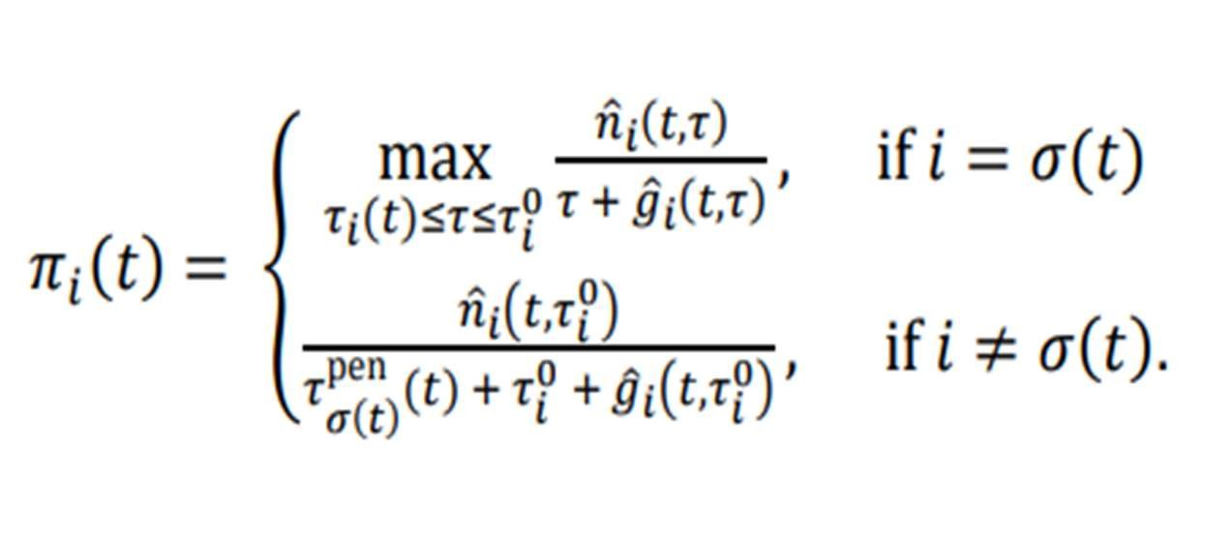

Two cases are distinguished depending on whether the signal 𝑖𝑖 is already selected or not. In either case, the equation basically divides the number of vehicles by the time needed to clear the queue including the (remaining) inter-green time. The priority index can, therefore, be interpreted as a clearance efficiency rate. Time horizon 𝜏 in the first case includes the effect of remaining inter-green time 𝜏𝑖(𝑡) for the selected signal (when it has not yet switched to green), and, simultaneously, a lookahead beyond the end of the current queue.

### ***REINFORCEMENT LEARNING***

With a growth in the economic sector since the early 1990s, India has been undergoing a paradigm shift in the domain of transportation as well. With the explosion in the number of road-vehicles, the surge in traffic density (especially in metropolitan cities like Bangalore and Delhi) has become a major cause of concern. It has, therefore, become really important to develop Intelligent traffic signals and systems in order to optimize the escalating traffic flow. For a developing country like India where the majority of motorists are still negligent of traffic laws and are often seen breaking them, for ex, driving in opposite lanes, violating an indicator near turns and turning in a wrong direction, and many more such instances which eventually lead to traffic jams.

In such Indian scenarios, the power of reinforcement learning applied on traffic behaviour can be leveraged to greatly reduce these traffic jams. We have designed a script for applying Deep Reinforcement Learning using SUMO simulator in the repository. We have used DQN +Target Network+ Experience Replay in our project and processed frames from simulator using computer vision.

REASEARCH BASED ON FUTURE TRAFFIC ENVIRONMENT

* The Overview of Future Traffic Environment Composition and Development: -

Nowadays, connected vehicles with highly self-driving functions (such as Google’s driverless vehicles, Tesla autopilot) and networked communications functions have completed several different driving conditions experiment or have been put into the market, and a variety of domestic and foreign auto companies and institutions have also entered the field of research.

The concept of intelligent connected vehicle was formed in the 1990s, known as cooperative infrastructure vehicle in the beginning. The earliest research on autonomous vehicles began in the 1980s, represented by the Naval Self-Driving Vehicle In the theoretical study, Levinson et al. optimized the existing automatic driving system, which enabled the vehicle adapted to a variety of lighting, weather, and traffic conditions, to a certain extent, overcoming the challenges of narrow roads, crosswalks, and signal intersections.

* Research Status of Traffic Signal Control System Based on Future Traffic Environment: -

Following the methods of earliest fixed signal timing and offline delay calculation proposed by Webster the traffic signal control system has evolved from offline to online control, from point to network control, from fixed-time to self-adaptive control. With the development of intelligent transportation system, the research of a new generation of traffic control technology based on multisource heterogeneous data has been gradually started. In recent years, the research on signal control based on cooperative infrastructure vehicle system has become the frontier Feld of domestic and foreign traffic control theory and application.

The research of intelligent connected vehicle was mainly focused on the optimization methods of traffic safety, such as collision warning and lane changing assistance. With the concept of active safety and traffic signal control problems being put forward, driving optimization strategy for efficiency and emission reduction, such as the speed guidance strategy considering the signal light state, eco driving strategy, and so on, has been widely studied. Besides, to meet the special needs like emergency rescue vehicles and bus priority, the multimode signal priority control system considering the real-time status of special vehicles has also been put forward and achieved initial implementation. Automatic driving research mainly focuses on the data collection and forecasting problem of mixed traffic few and the local optimization method based on the rolling optimization strategy. Most of the optimization targets adopt efficiency-related indicators such as the least delay, the least number of stops, or the shortest across time. About the control effect evaluation, most of the research output optimization control effect based on the secondary developed traditional simulation software. Researches show that the traffic control which considers the mixed traffic few of the connected vehicle.

### ***ALGORITHMS FOR THE SMART TRAFFIC CONTROL SYSTEM***

EVSP PROCESS

Four components are interacted in the EVSP sequence diagram, which are OBU, RSU controller, traffic signal controller, and CMS. The interaction messages sequence can be divided into two phases, before and after the EV passed through the intersection, which are mapping to the seven stages illustrated in Figure The RSU controller collects the EV message, decides if it should be responsible for the EV (host RSU), controls the signal control, and displays messages on the CMS. After EV passes through the intersection, the RSU controller switches back the signal, CMS, and starts traffic compensation.

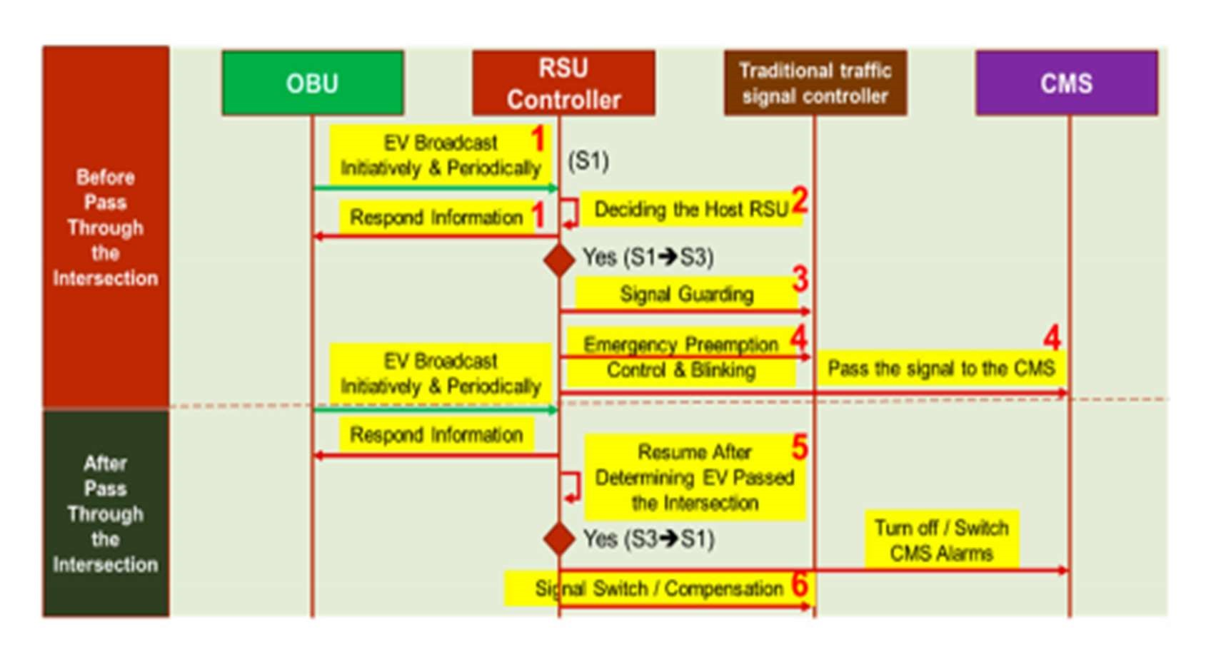

Sequence diagram of the EVSP mode.

The major component where the EVSP control algorithm executed is the RSU controller, where the system flowchart is shown in Figure 6. The EVSP algorithm processes the OBU message, identifies the vehicle type and status (A), determines if it is the host RSU by the Host RSU algorithm (B), entering the EVSP state, and running the traffic signal control algorithm (C), determining if OBU leaves the intersection (D), and switches to the compensation mod

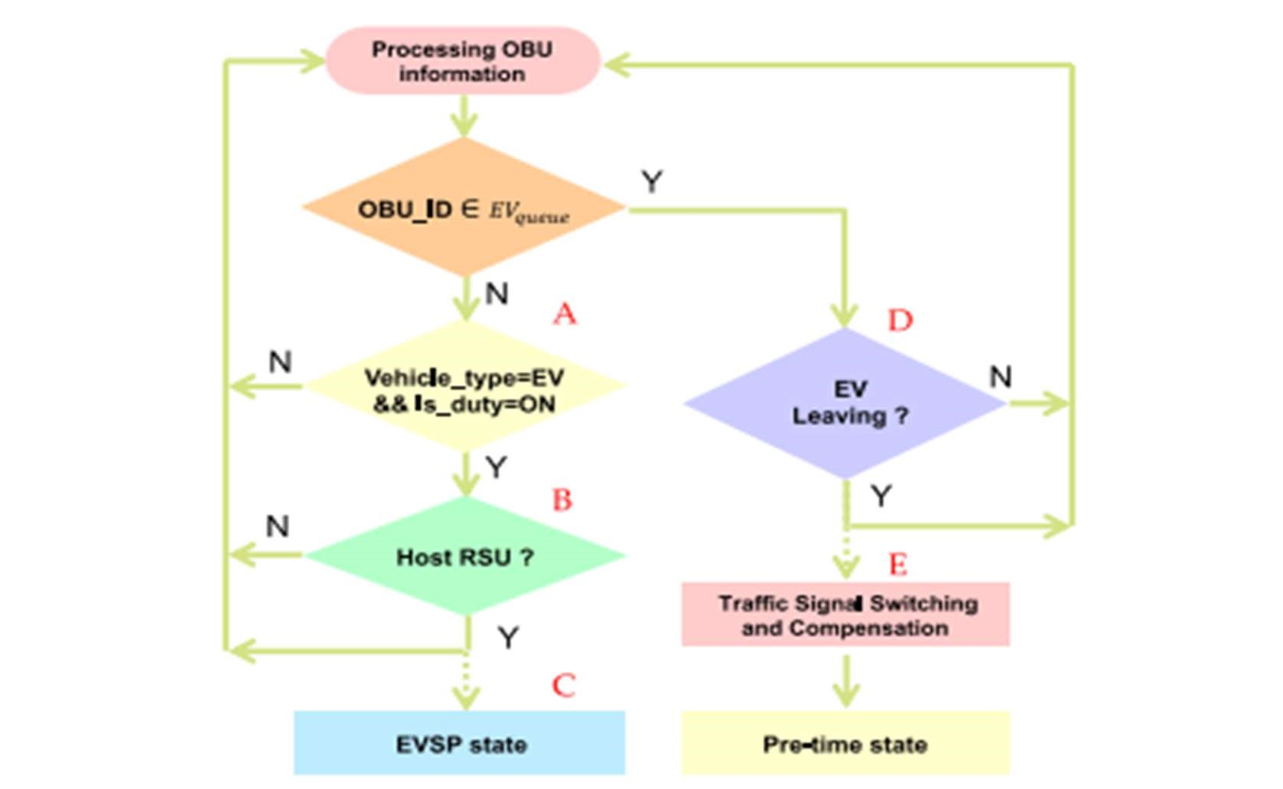

EVSP Algorithm

7.1. TRAFFIC SIGNAL CONTROL ALGORITHM

After the host RSU check, the RSU starts the EV signal pre-emption control process, where the control algorithm of this process is presented in Figure 9. RSU reads the current signal plan from the traffic signal controller, determining whether to extend the green period or cut off the red period to facilitate the EV passing through the intersection. The green mode (G-mode) indicates that the EV direction is currently in the green period and that it should remain green until the EV passes the intersection. If the EV direction is currently in red mode (R-mode), the signal controller should turn to green as soon as possible but still has to follow the minimum green constraints to ensure the safety of pedestrians. A traffic signal guarding mode (Y-mode) is designed after the R-mode control is completed. The RSU judges the remaining green time of the signal in the non-EV direction. If Grt is smaller than minimum green protection time (𝐺min), R-mode will continue until Grt is greater than 𝐺min. It then enters the traffic signal guarding mode (Y-mode), where the RSU will convert the non-EV traffic light from yellow to red. The RSU controls the signal into green mode ( G-mode ) after Y-mode, and stays in G-mode until the EV leave

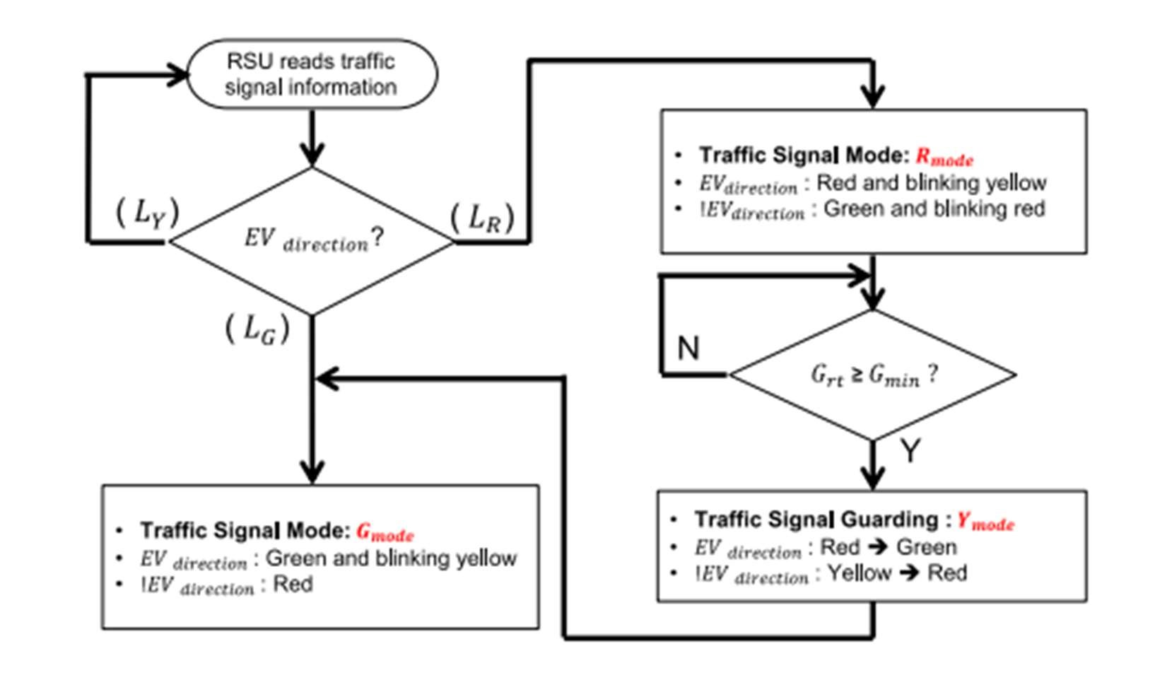

Traffic Signal Control Algorithms

Traffic Signal Mode: R-mode

In R-mode, where the current signal in the EV direction is red, RSU will begin the process of switching the signal to green as soon as possible to facilitate EV moving through the intersection, while the process still has to follow a minimum green constraint to ensure safety. The process of the R-mode scenario is illustrated in Figure 10. Assume that the EV is on emergency duty and approach the intersection from the south direction. If the signal is in a red period, the RSU will activate the R-mode procedure after it determines it is the host RSU. The red period will be cut off and smoothly switched to green due to the EV owning the priority. The traffic signal control algorithm controls the signal and displays red and blinking yellow (instead of the red) in EV moving directions, and green and blinking yellow (instead of green) in cross directions. This signal scheme as well as the message shown in CMS are specially designed to inform all the vehicles and passengers from which direction the EV is coming and how to move for giving way. Another important issue is that the minimum green constraint (G-min) should be followed for the pedestrian protection; this period is the traffic signal guarding mode shown in Figure 10. After traffic signal guarding, the control algorithm switches to the Y-mode, which includes a short blinking yellow followed by an all red interval, which is the interaction clearance interval for clearing the intersection to ensure safety. In EV pre-emption control and blinking stage, the algorithm controls the signal in EV directions with green and blinking yellow to signal to other vehicles, and red for crossing directions to stop vehicular conflict. Once the RSU detects that the EV is leaving the intersection (discussed later in Section 4), it switches back the signal and conducts the compensation process (discussed in Section 5).

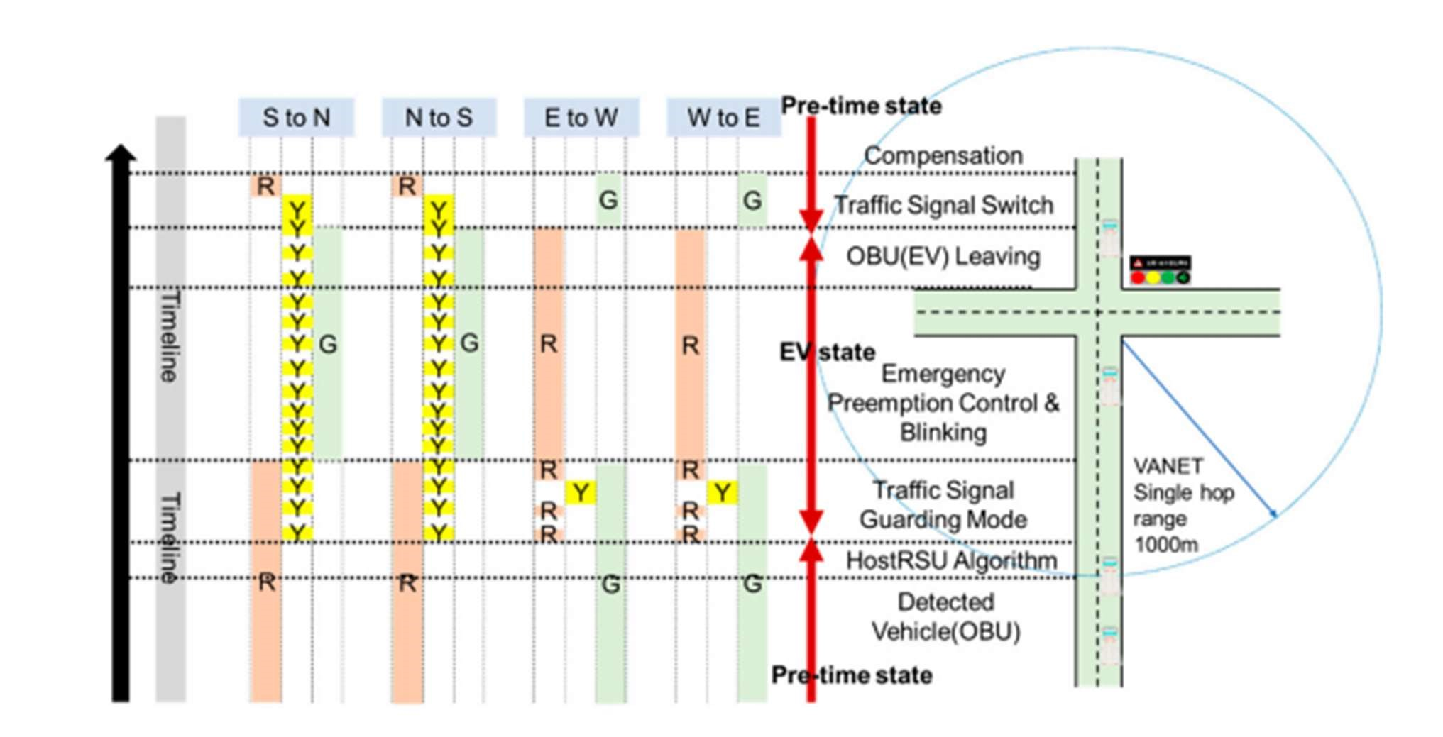

Traffic Signal Blinking Mode (R-mode)

Traffic Signal Mode: G-mode

In G-mode, the traffic signal in EV directions is originally green, the task of the control algorithm is to maintain or extend the green period, clearing the vehicles in front of the EV to facilitate it moving through the intersection. The signal control process of G-mode is illustrated in Figure 11, it extends the current green phase and controls the signal in green and blinking yellow in EV directions (S to N, N to S), and stays red in crossing directions (E to W, W to E). The extending green period that should be compensated after EV leaves the intersection is discussed in Section 4.5.

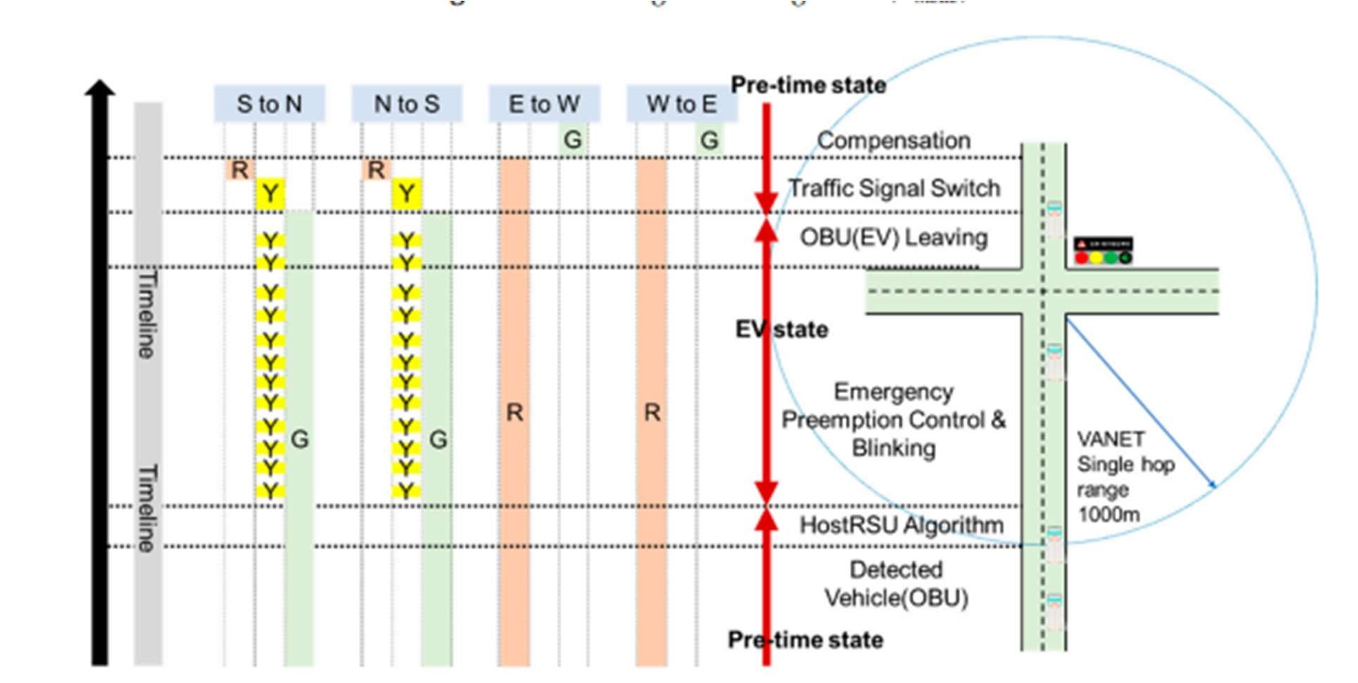

Traffic Signal Blinking Mode (G-mode)

#### OBU Leaves the Intersection Process

When the RSU is in EVSP state, it continuously monitors the state and position of the EV and determines if the EV leaves the intersection. As shown in Figure 12, the RSU starts a timer (RSU timer), and continuously monitors if it is timeout or violates the maximum green constraint. The purpose of the timer is to prevent the RSU from staying in an EVSP state if information broadcasted by OBU without being received after EV leaves the intersection.

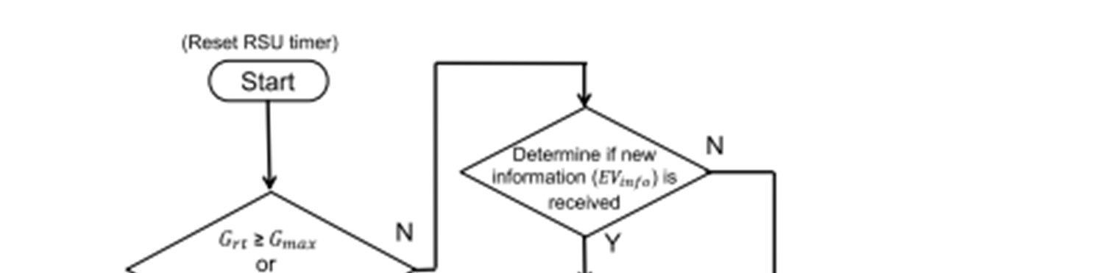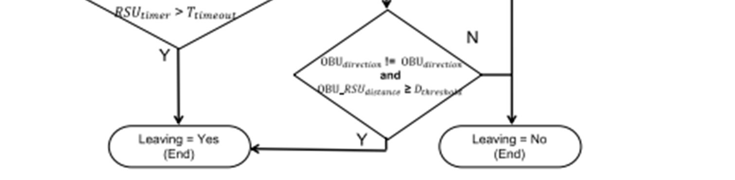

The algorithm of determining if OBU leaves the intersection.

#### Traffic Signal Switching and Compensation Mode

After the EV has passed through the intersection, the RSU switches back to original signal phase and starts the traffic flow compensation. The purpose of the compensation mechanism is to improve the vehicle’s continuation rate and reduce the unnecessary stagnation. Two compensation modes including positive compensation and negative compensation are designed, as shown in Figure 13, which enables the proposed STSC system to reduce the time of the signal coordination and is backward compatible with legacy traffic signal controllers. The RSU will switch to negative compensation mode if the current signal phase is more than half; otherwise, it switches to the positive compensation mode. Sensors 2020, 20, x FOR PEER REVIEW 13 of 19 Figure 12. The algorithm of determining if OBU leaves the intersection. 4.5. Traffic Signal Switching and Compensation Mode.

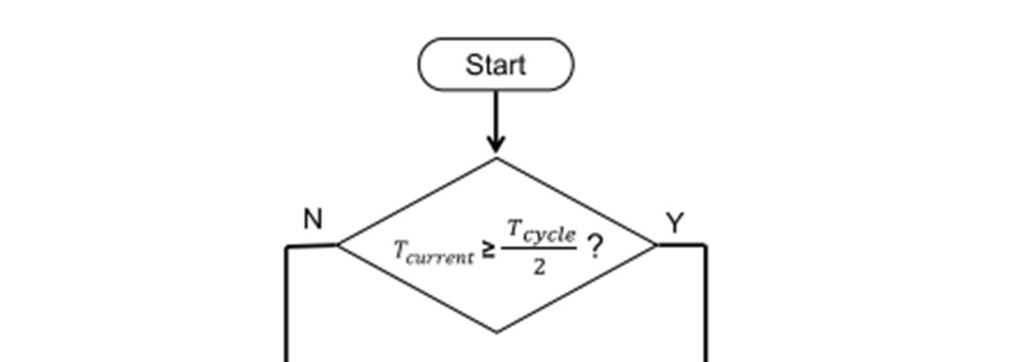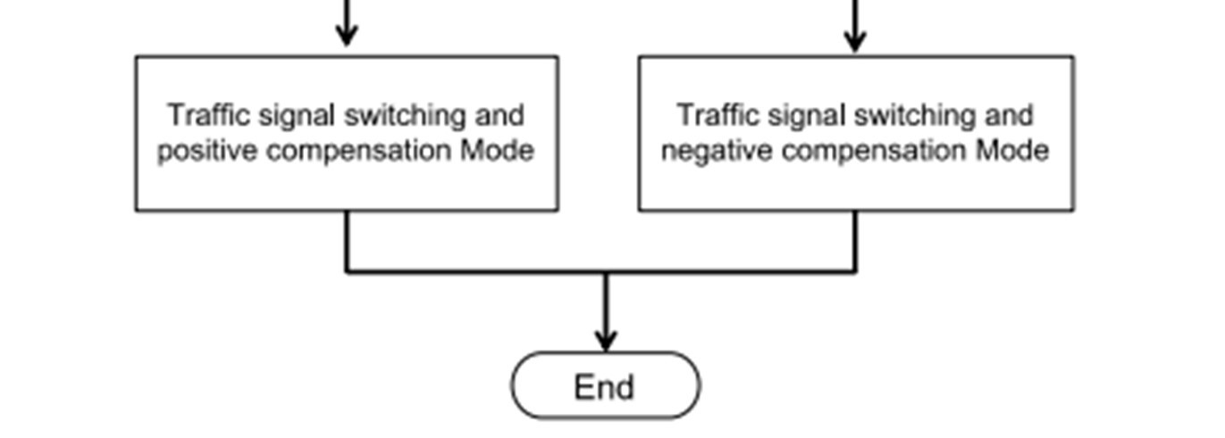

Traffic Signal Switching and Compensation Mode

#### **CONCLUSION AND FUTURE WORKS**

In this paper, a multi-modal smart traffic control system (STSC) for the infrastructure in the smart city is proposed, which can be widely applied for the intelligent transportation system in smart city applications. The major components in the proposed STSC include RSU controller, OBU, signal controller, and cloud centre. It supports various smart city ITS applications including EVSP, TSP, eco driving, ATSC, pre-time signal control, and R2V message broadcasting.

The RSU controller is the core of this work, where we discuss in detail the system architecture, middleware, peripheral hardware modules, and control algorithms. The STSC system designed follows the urban traffic control protocol V3.0 so that it is compatible with a traditional traffic signal controller and can be fast and cost-effectively deployed. A new traffic signal scheme is specially designed for the EVSP scenario; it can inform all the drivers near the intersection when EV is approaching, smoothing the traffic flow and enhancing the safety without extra hardware costs.

In the future, real-time traffic information fusion for ATSC by integrating multiple data sources such as loop detector and smart AVI is to be designed. Design details for TSP and ATSC applications should be further implemented. Kernel optimization in middleware modules such as message handling, state transition, and parallel processing are planned to be implemented. Cooperated RSU controllers for optimizing EVSP, TSP, or ATSC can be further studied to enhance the efficiency of public transportation.

##### ***REFERENCES***

1. UN DESA. World Population Prospects 2019: Highlights (ST/ESA/SER. A/423); United Nations Department for Economic and Social Affairs: New York, NY, USA, 2019.
2. Nellore, K.; Hancke, G. A survey on urban traffic management system using wireless sensor networks. Sensors 2016, 16, 157. [CrossRef] [PubMed]
3. C-IST Platform. Certificate Policy for Deployment and Operation of European Cooperative Intelligent Transport Systems (C-ITS); European Commission: Brussels, Belgium, 2017.
4. Jiang, D.; Delgrossi, L. IEEE 802.11p: Towards an international standard for wireless access in vehicular environments. In Proceedings of the VTC Spring 2008-IEEE Vehicular Technology Conference, Singapore, 11– 14 May 2008; pp. 2036–2040.
5. Savolainen, P.; Datta, T.; Ghosh, I.; Gates, T. Effects of dynamically activated emergency vehicle warning sign on driver behavior at urban intersections. Transp. Res. Rec. J. Transp. Res. Board 2010, 2149, 77–83. [CrossRef]
6. Qin, X.; Khan, A.M. Control strategies of traffic signal timing transition for emergency vehicle preemption. Transp. Res. Part C Emerg. Technol. 2012, 25, 1–17. [CrossRef]
7. Al-Dweik, A.; Muresan, R.; Mayhew, M.; Lieberman, M. IoT-based multifunctional scalable real-time enhanced road side unit for intelligent transportation systems. In Proceedings of the 2017 IEEE 30th

Canadian Conference on Electrical and Computer Engineering (CCECE), Windsor, ON, Canada, 30 April–3 May 2017; pp. 1–6.

1. Asaduzzaman, M.; Vidyasankar, K. A Priority Algorithm to Control the Traffic Signal for Emergency Vehicles. In Proceedings of the 2017 IEEE 86th Vehicular Technology Conference (VTC-Fall), Toronto, ON, Canada, 24– 27 September 2017; pp. 1–7.
2. Ahn, S.; Choi, J. Internet of vehicles and cost-effective traffic signal control. Sensors 2019, 19, 1275. [CrossRef] [PubMed]
3. Pandit, K.; Ghosal, D.; Zhang, H.M.; Chuah, C.N. Adaptive traffic signal control with vehicular ad hoc networks. IEEE Trans. Veh. Technol. 2013, 62, 1459–1471. [CrossRef]